TEST PLAN FOR POSTMAN:

- Application health check:
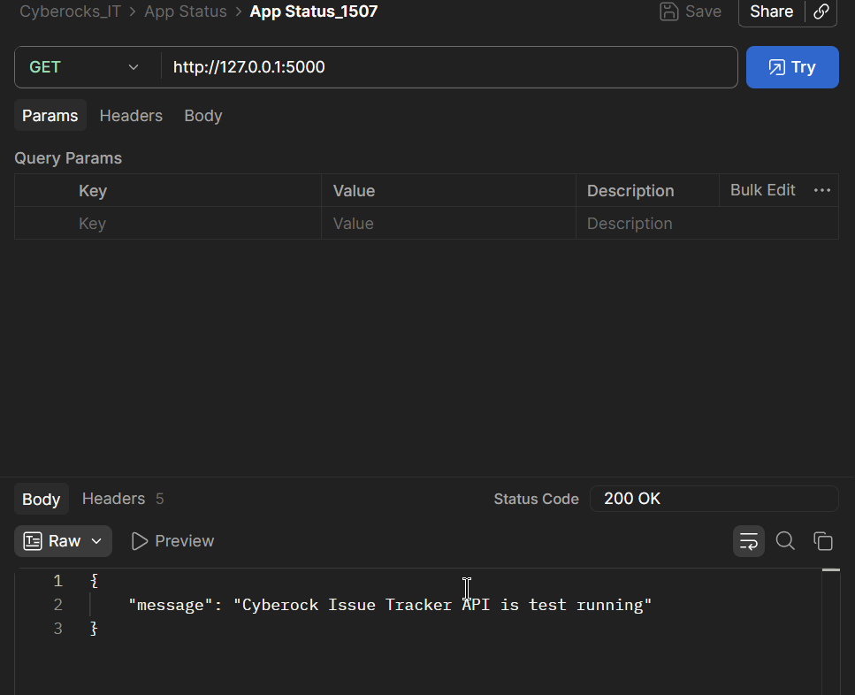

- POST: creates tickets as per all valid inputs
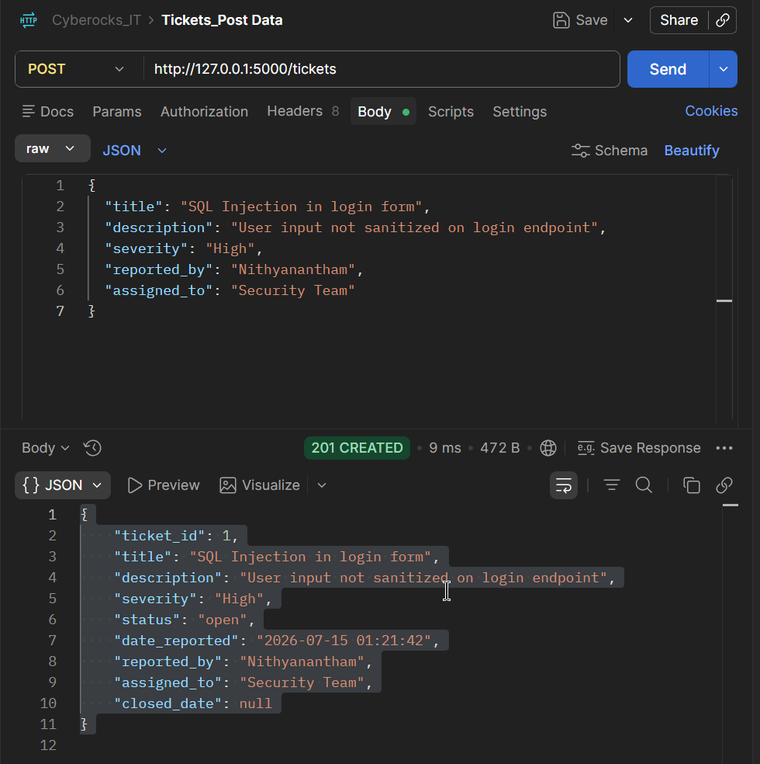

- Missing valid input error , tested with omitting reported_by in the input request
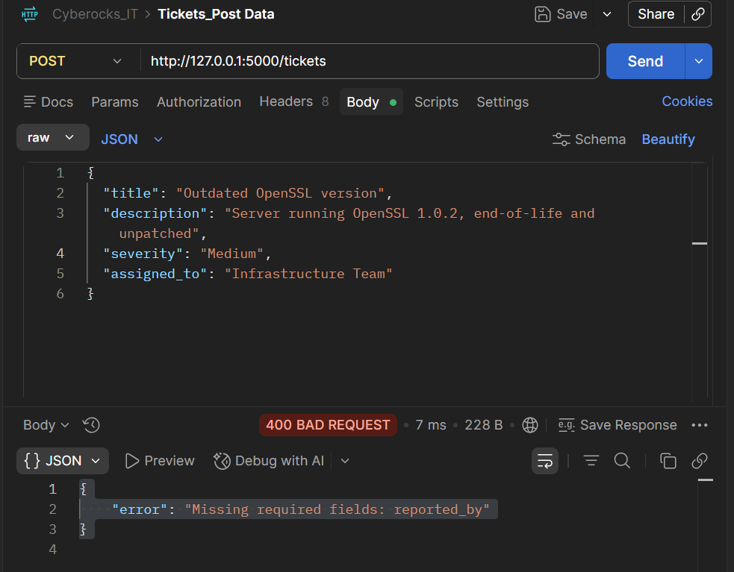

- Missing all valid inputs like title, description, reported_by
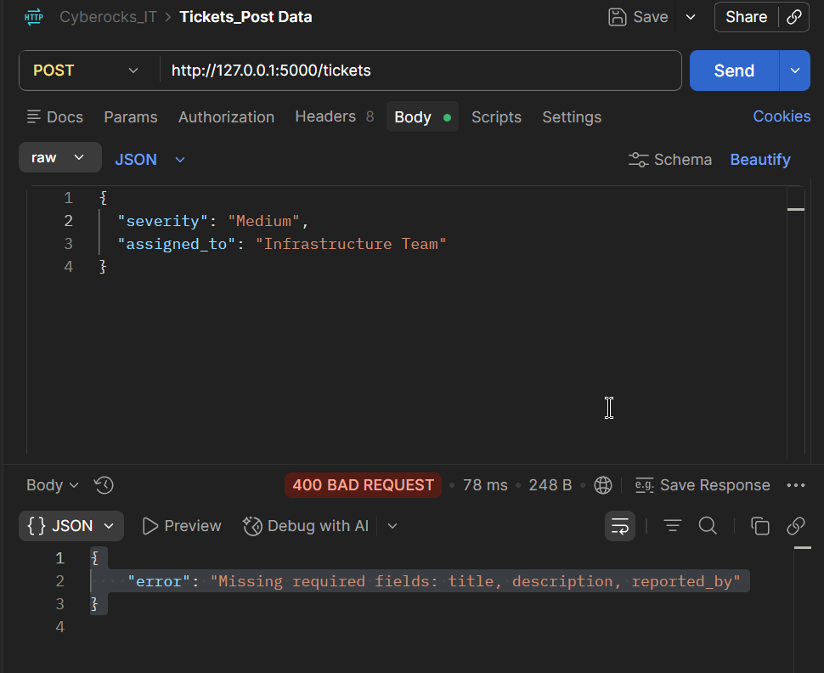
- Missing severity or assigned_to (optional)
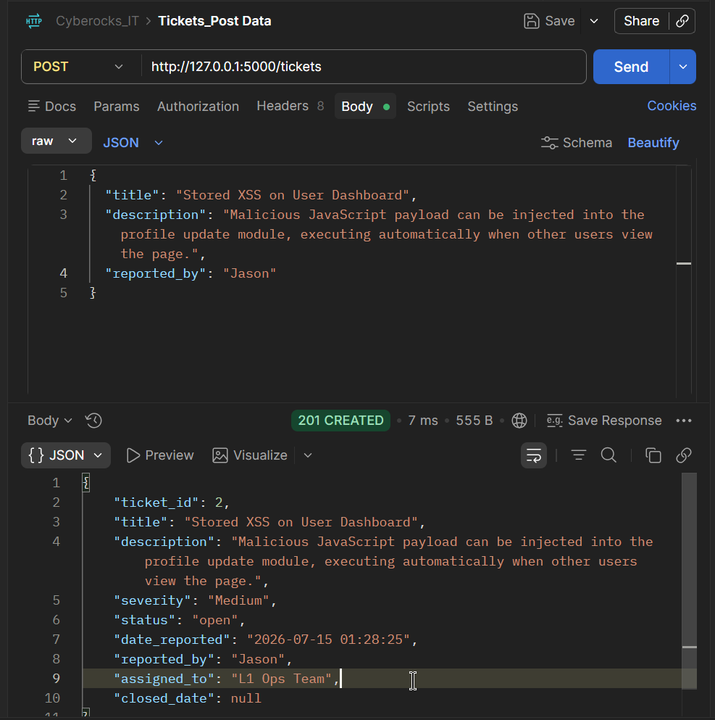

- Empty string or incorrect value not in allowed list (severity,assigned_to)
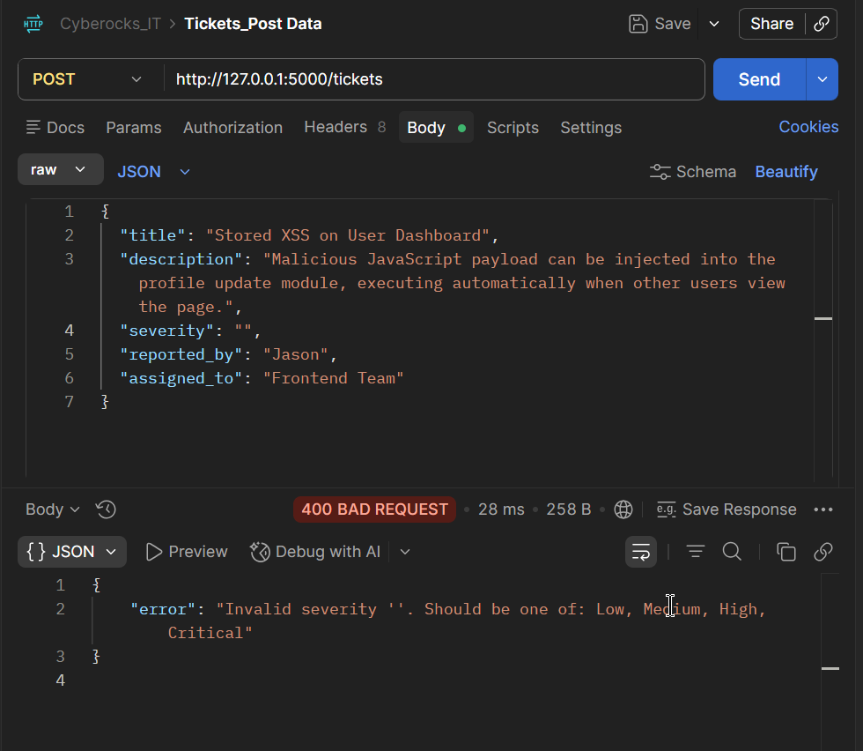
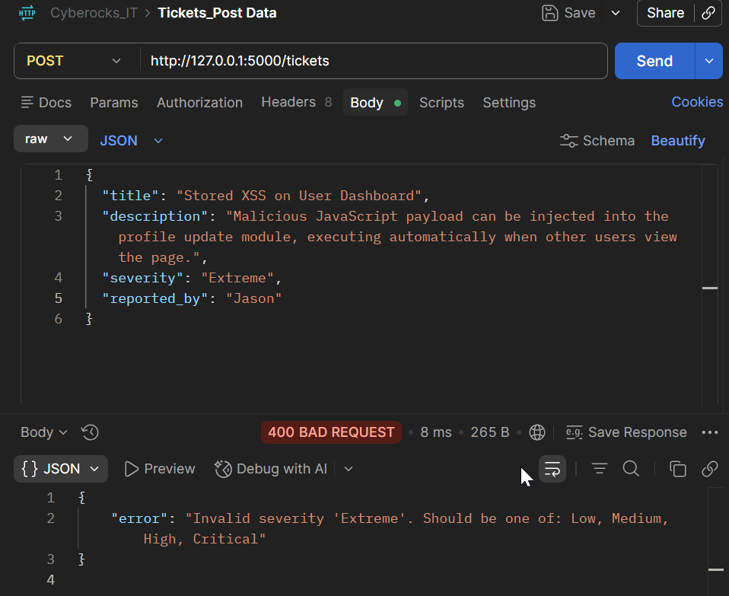
- Ticket id is incrementing
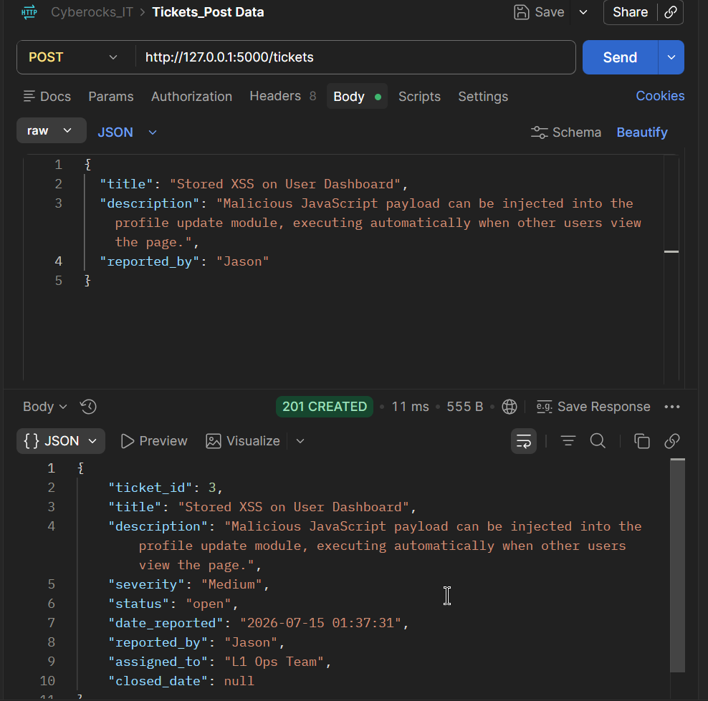

- Status assigned to ticket always to open even if user sends different value
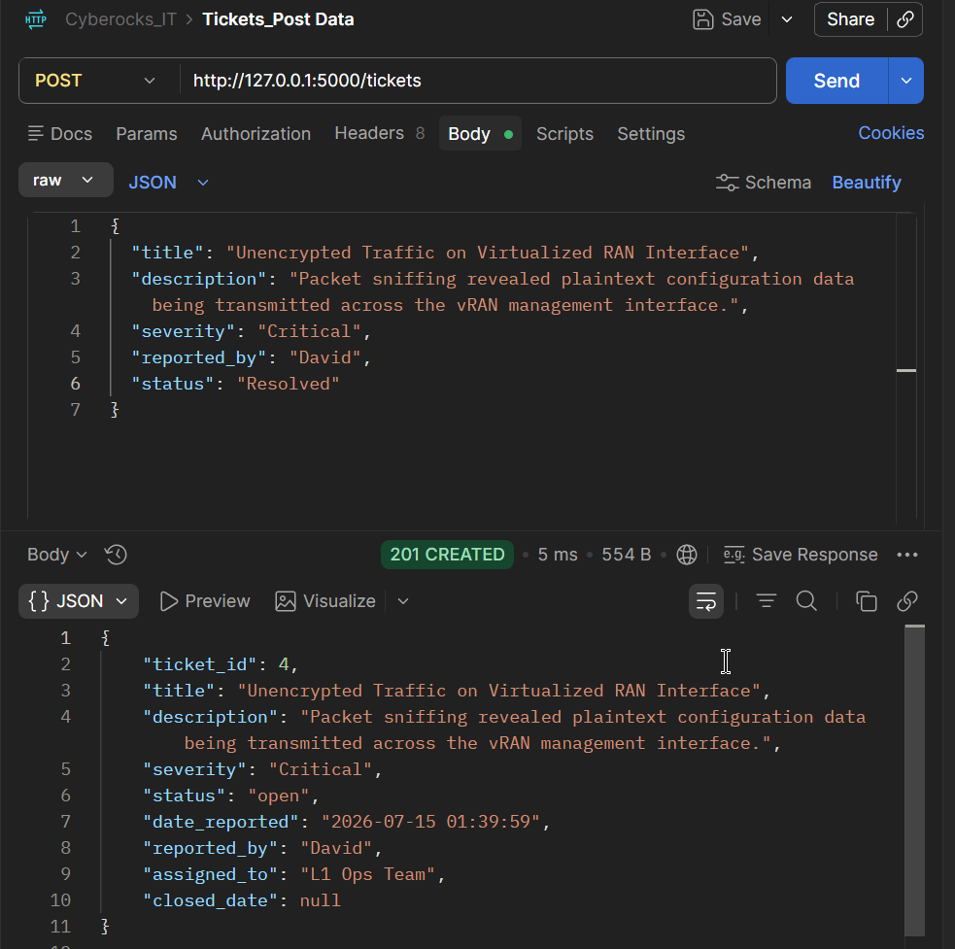
- Get tickets list all tickets from memory
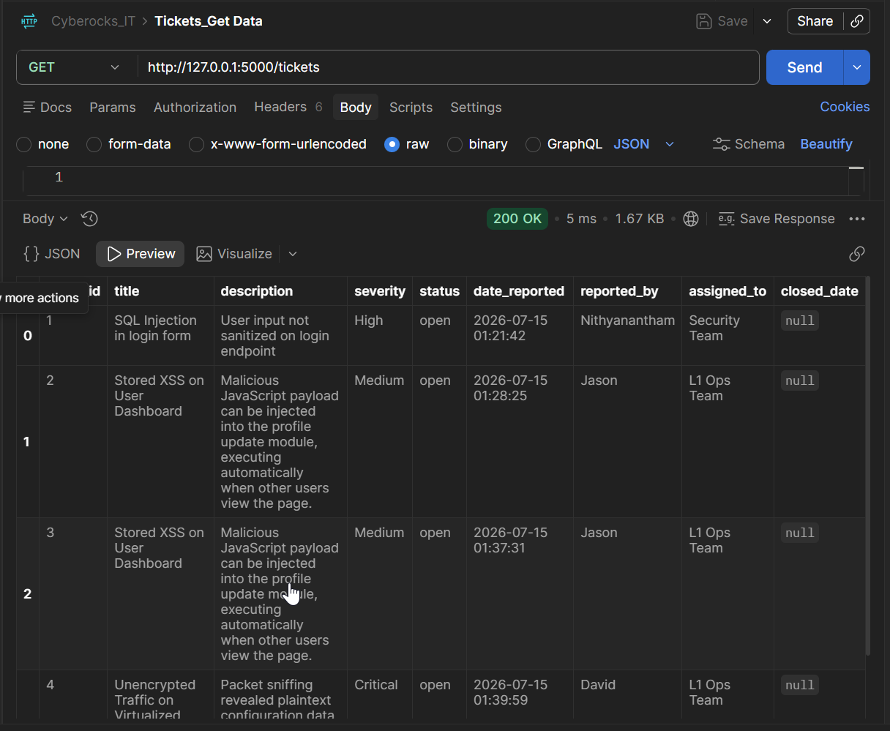

- Get Ticket id
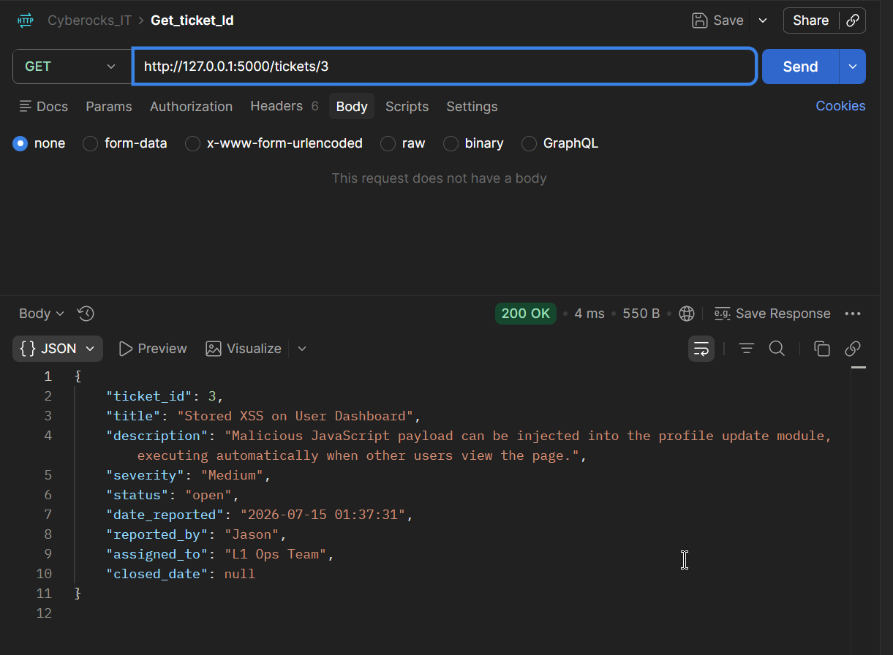
- Get ticket which is not created
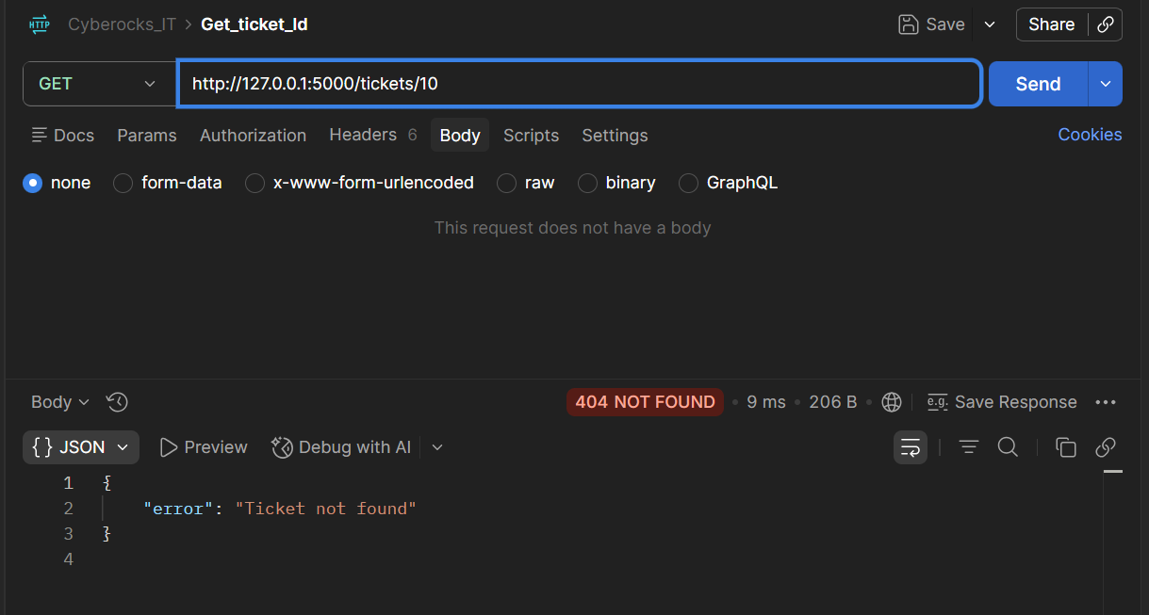
- Status update for Ticket
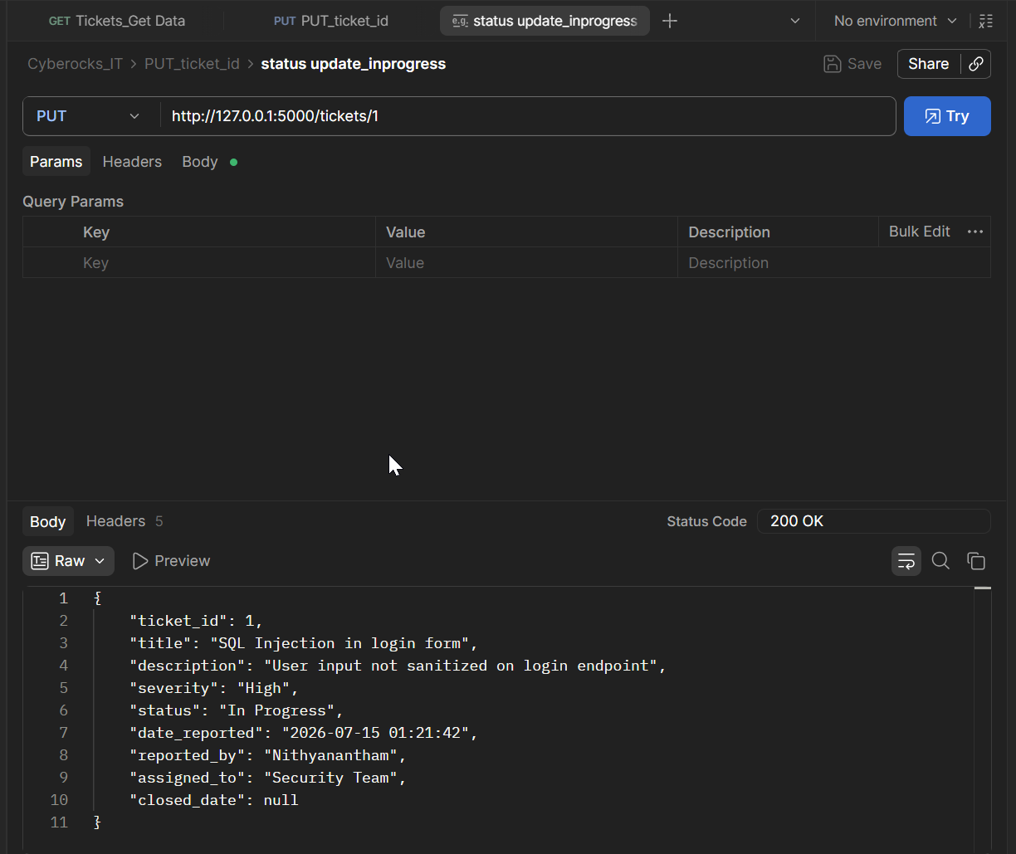
- Update status and severity
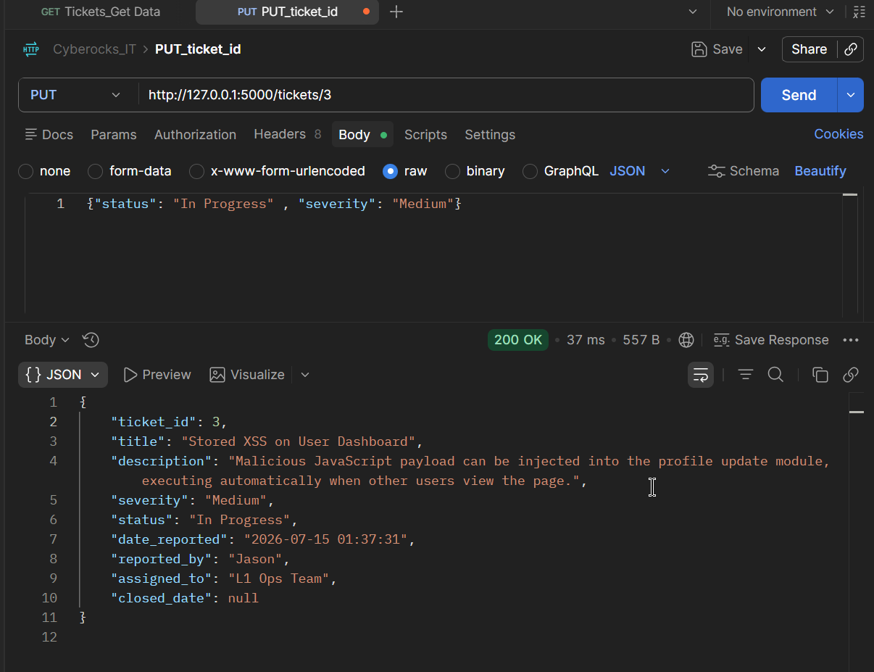
- Update incorrect severity
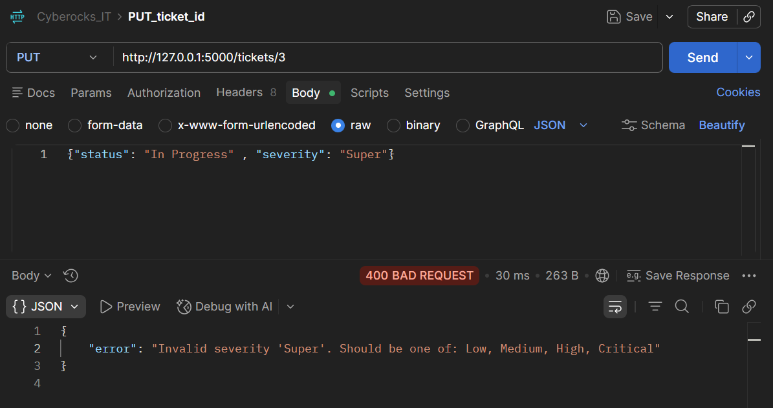
15.Update incorrect status 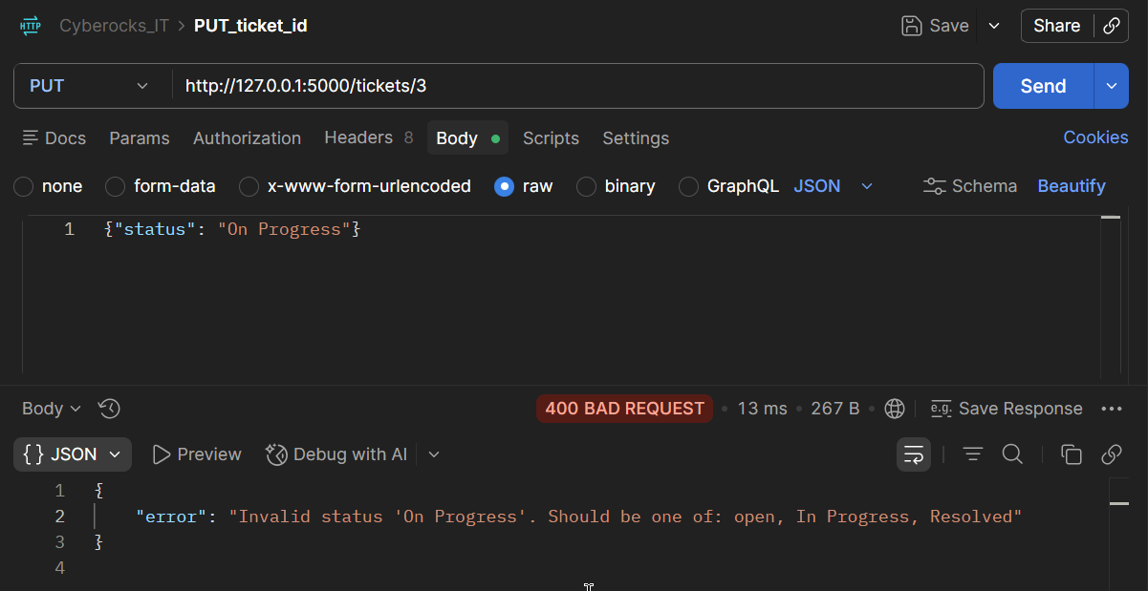
16. Incorrect assigned_to
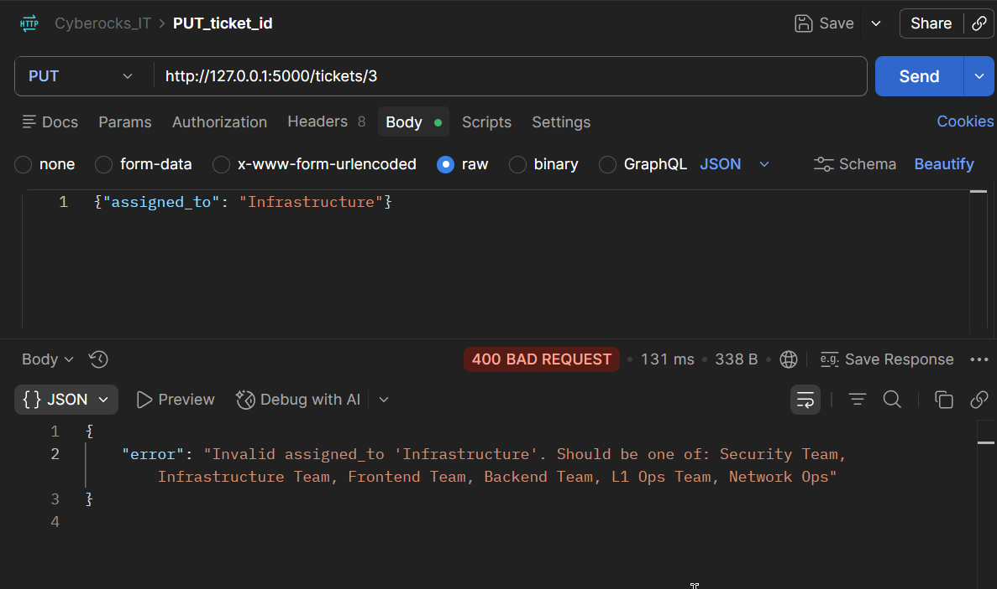
17. Status resolved and closed_date update by system
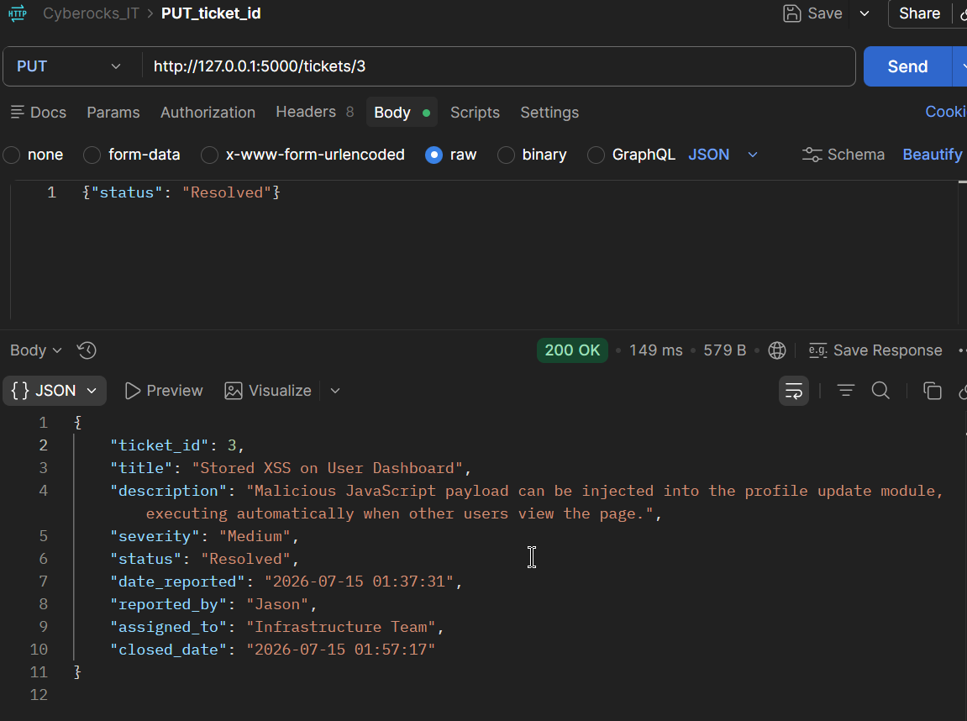
18. Resolved to open and closed_date cleared
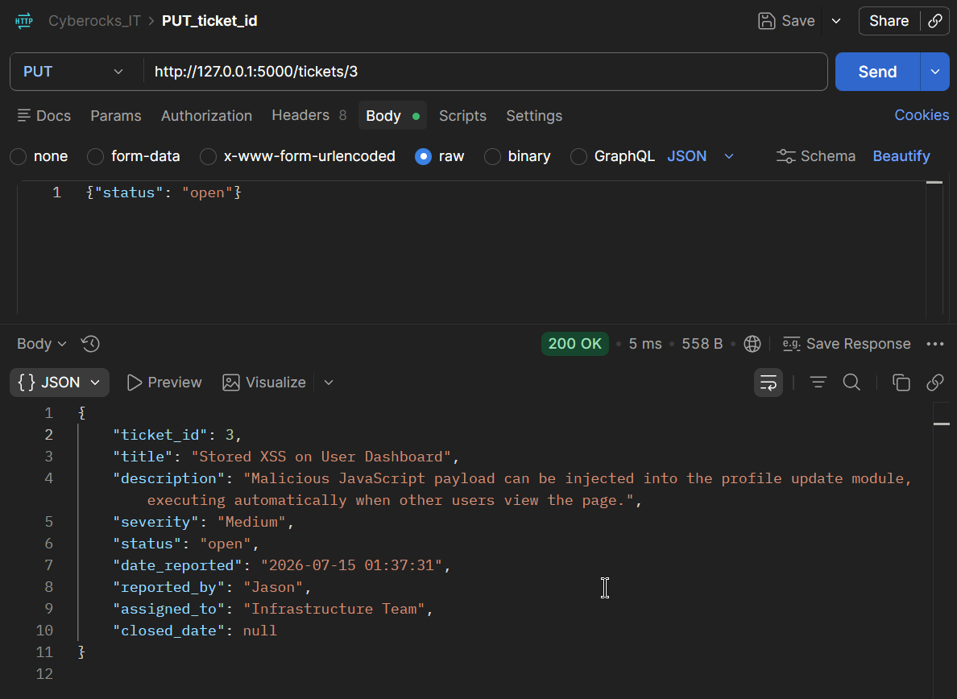
19. Ticket update for not available ticket
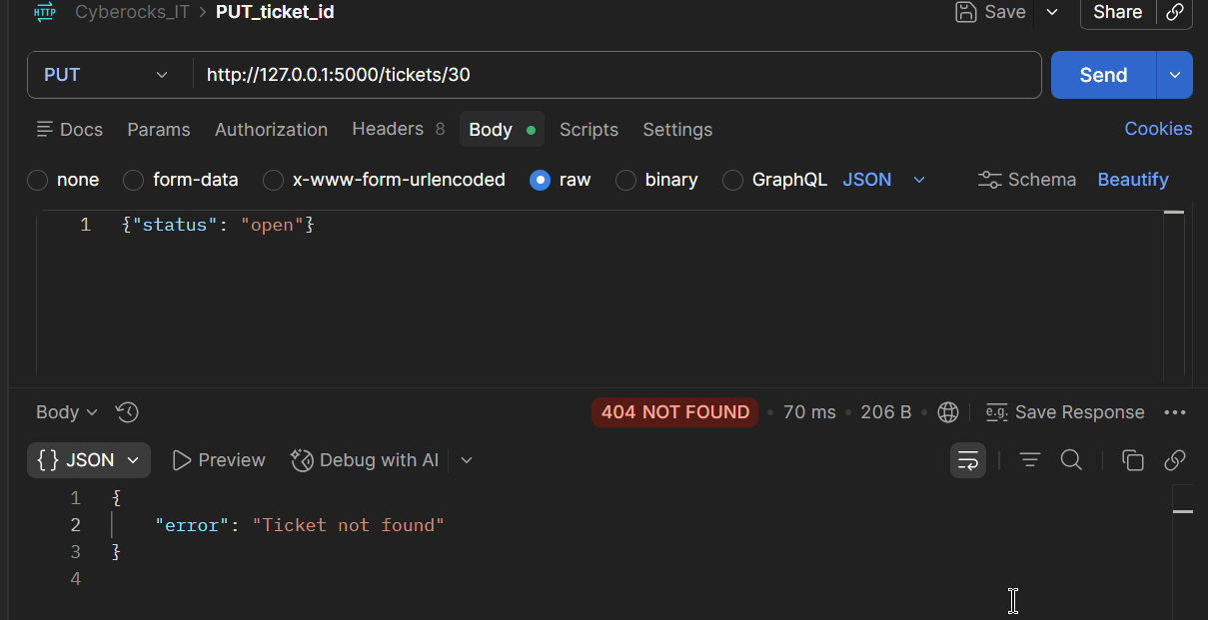
20. DELETE not found ticket
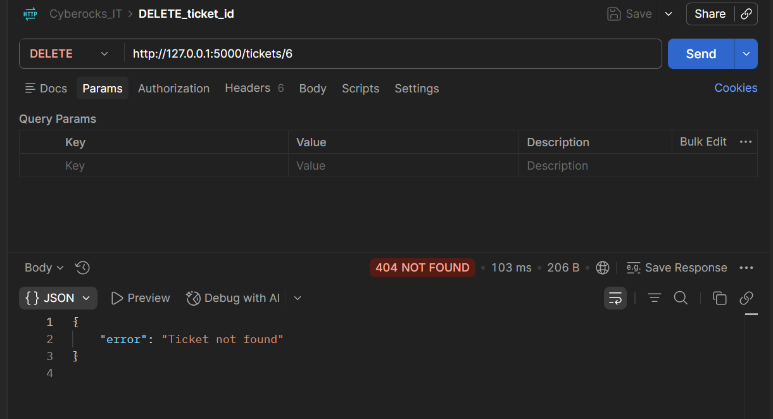

21. DELETED TICKET 2
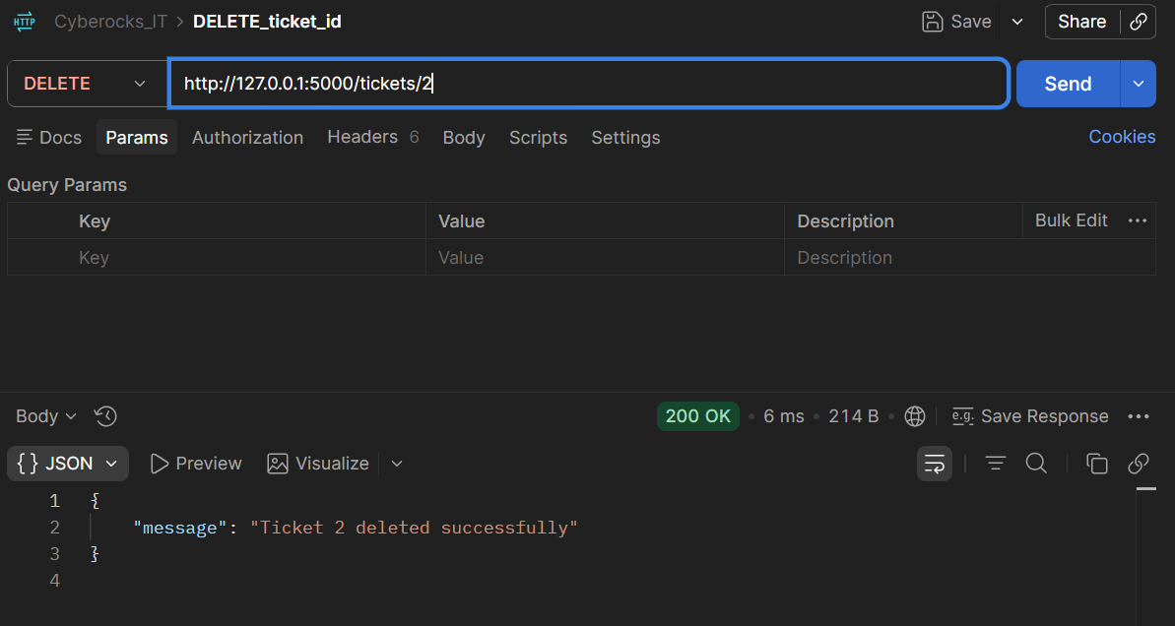
22. Deleted ticket 2 not available in GET tickets
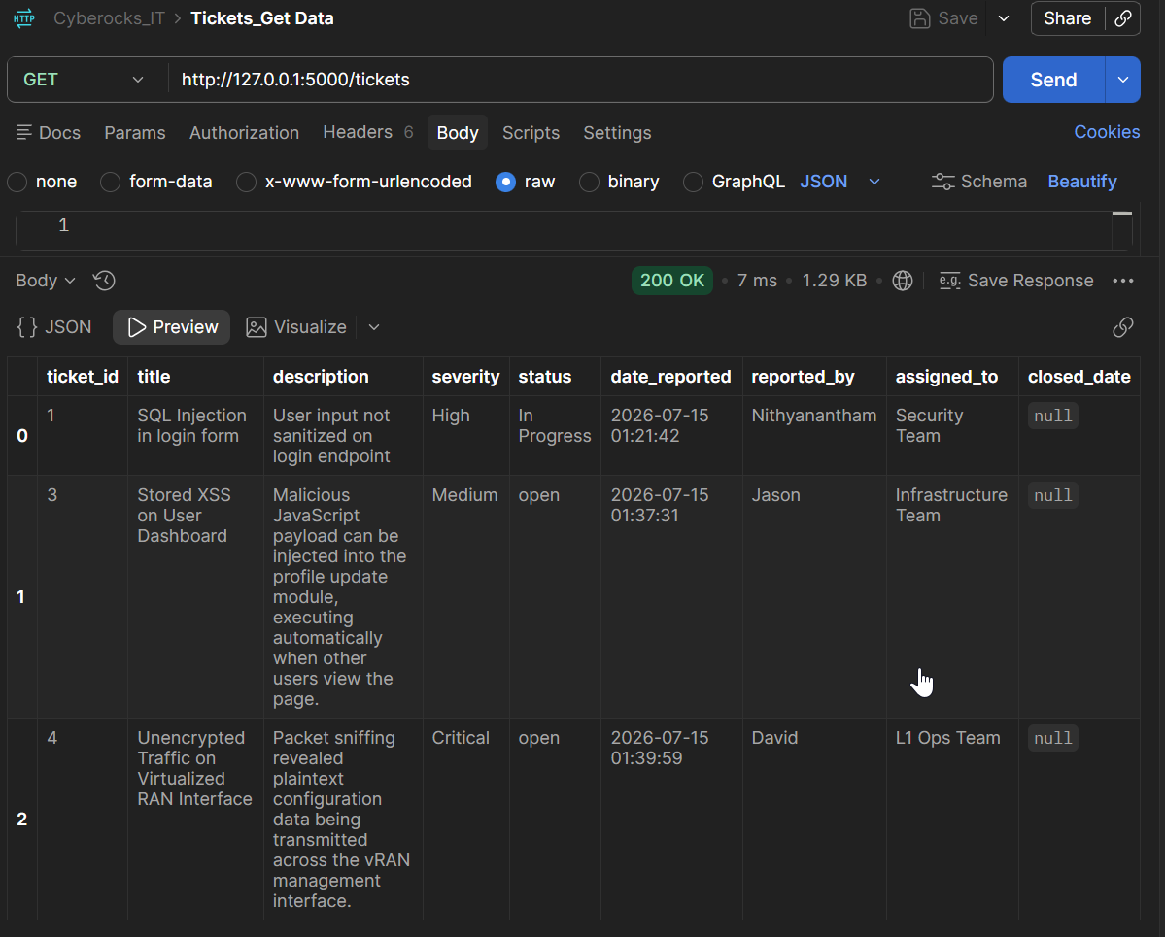
23. SERACH SQUERY with SQL
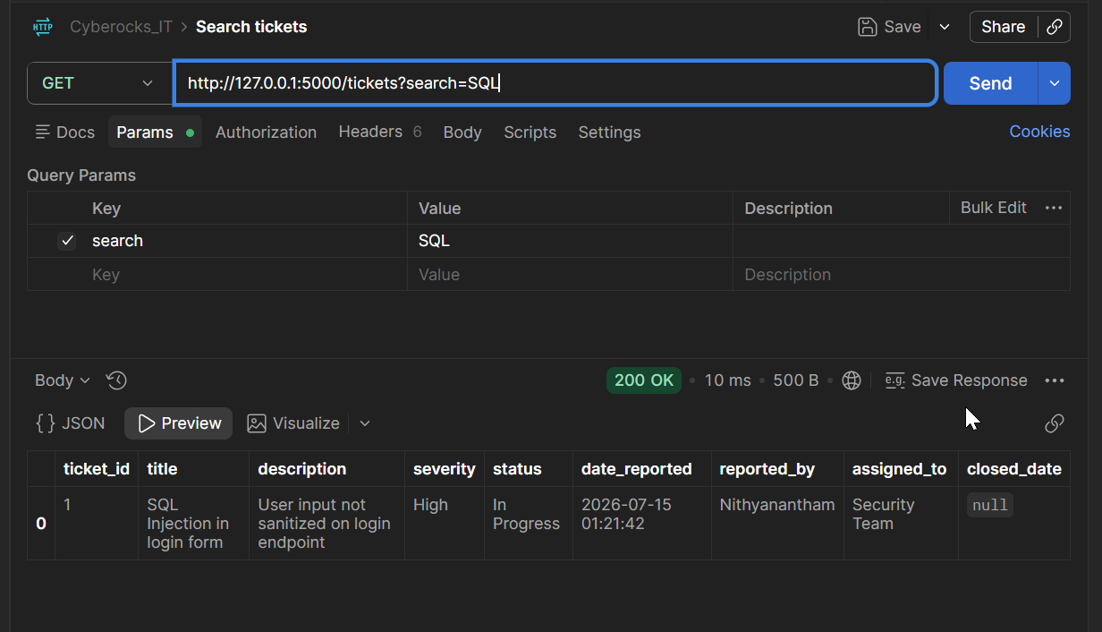
24. Search with incorrect value zzz
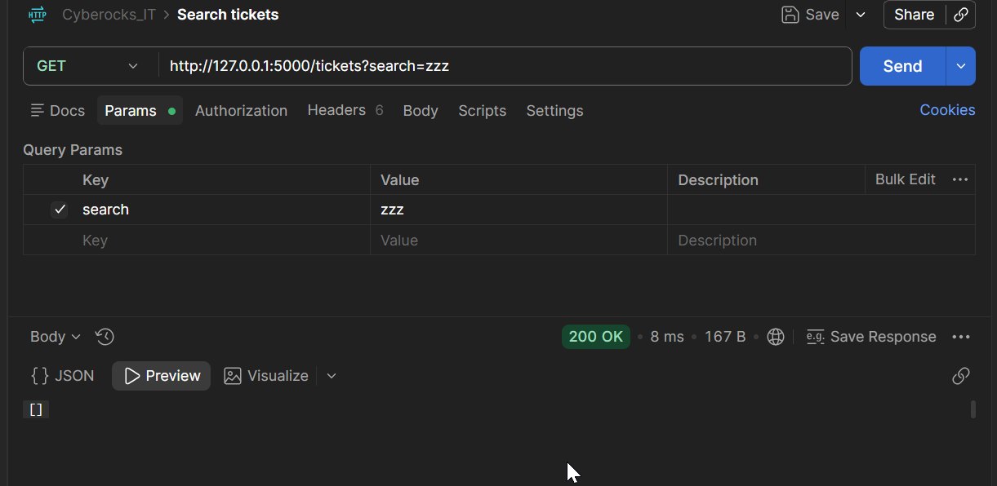
25. SEARCH sql
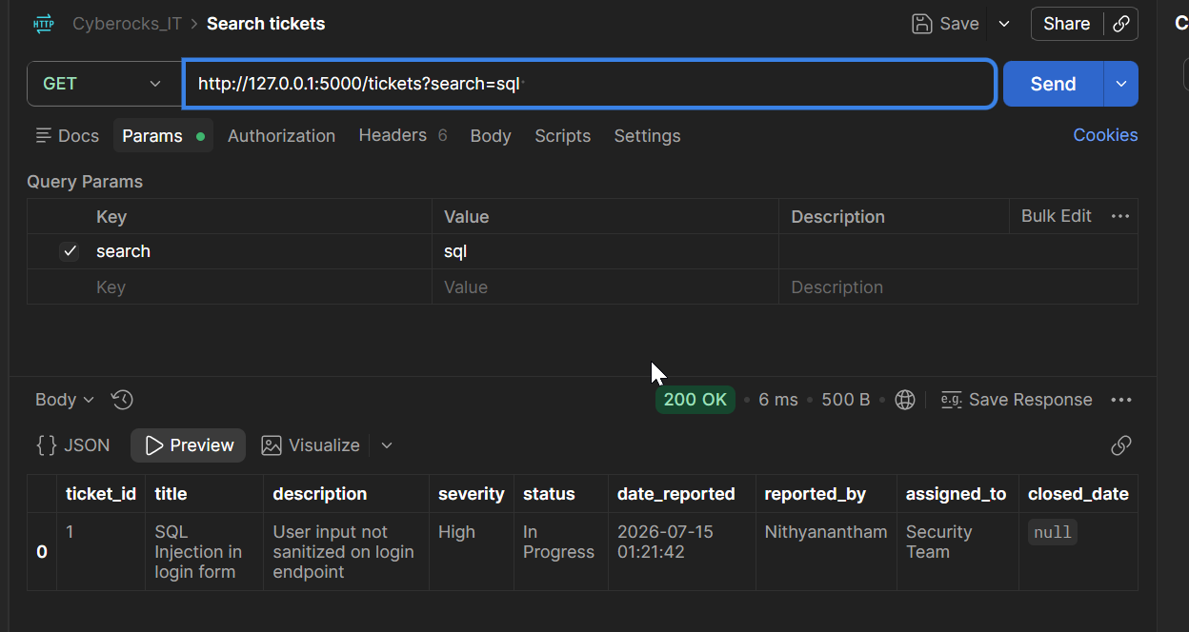
26. Filter severity =High and status = open
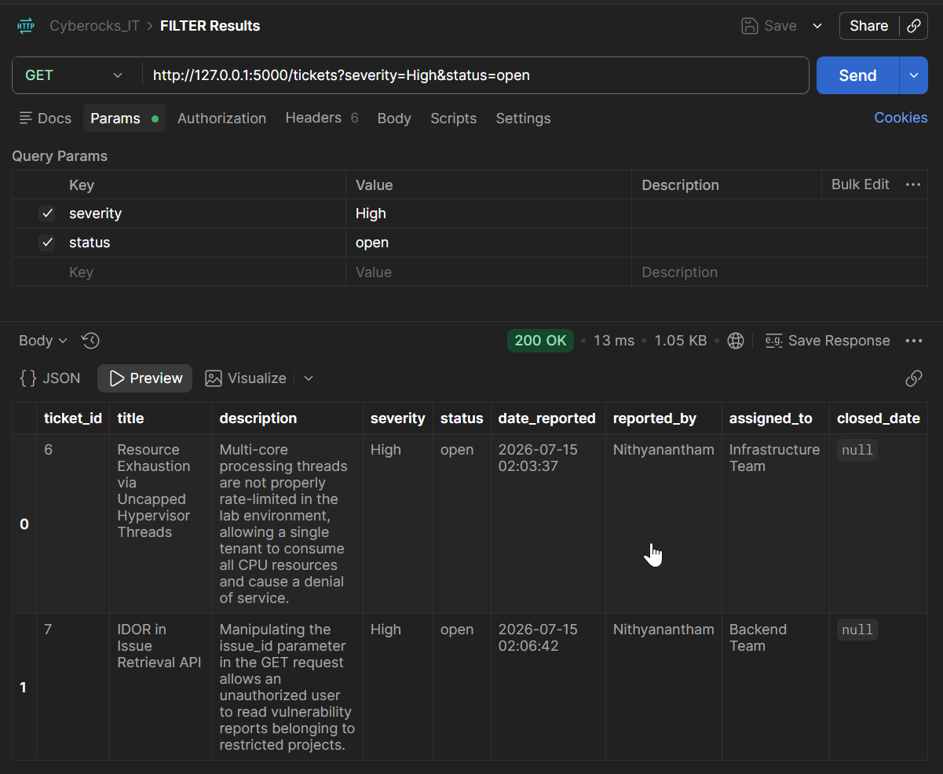
27. FILTER severity = High
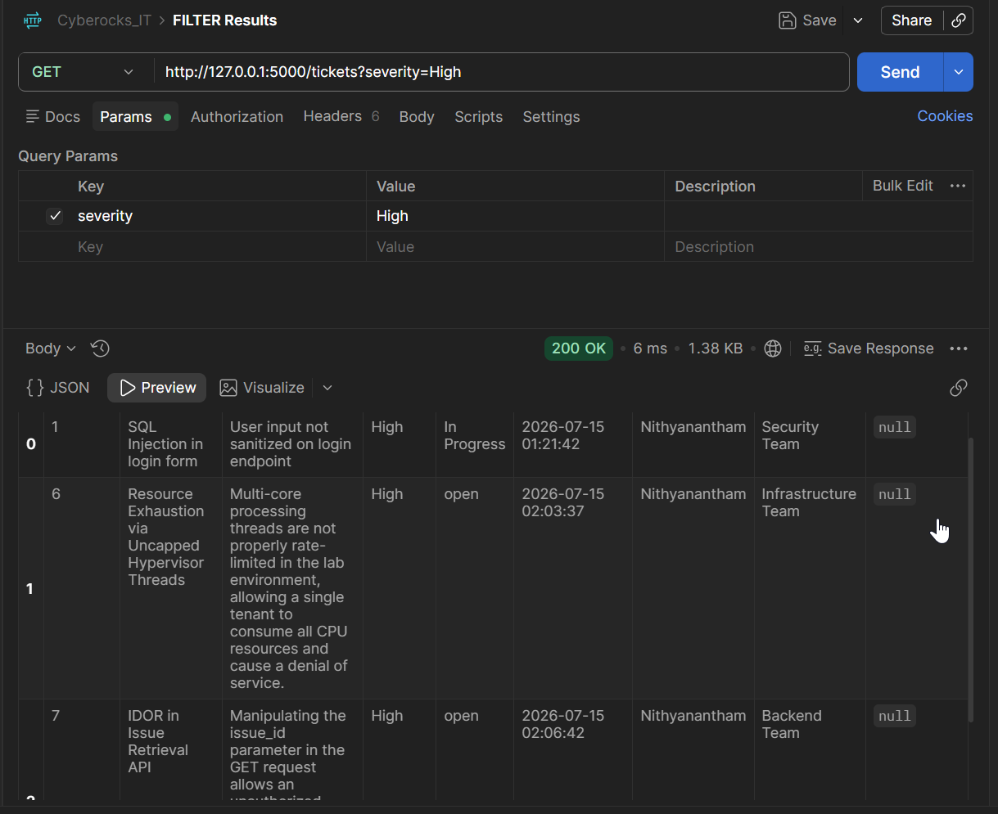
28. combined search = SQL & severity=High
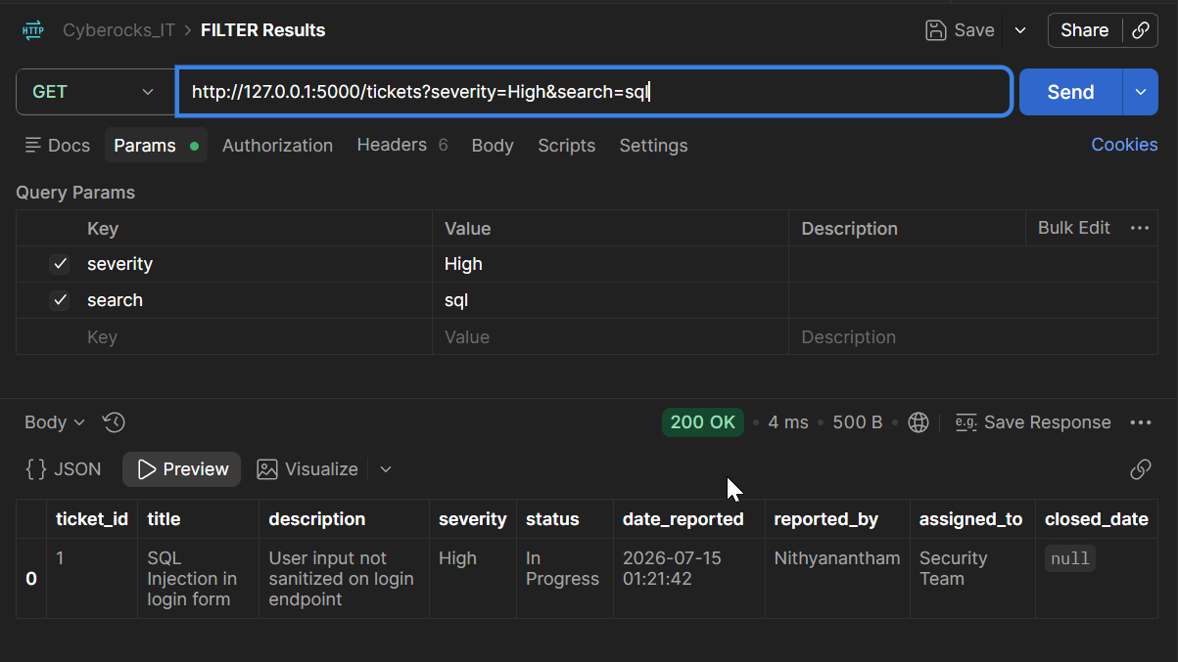
29. combined sort=date_reported & severity=High
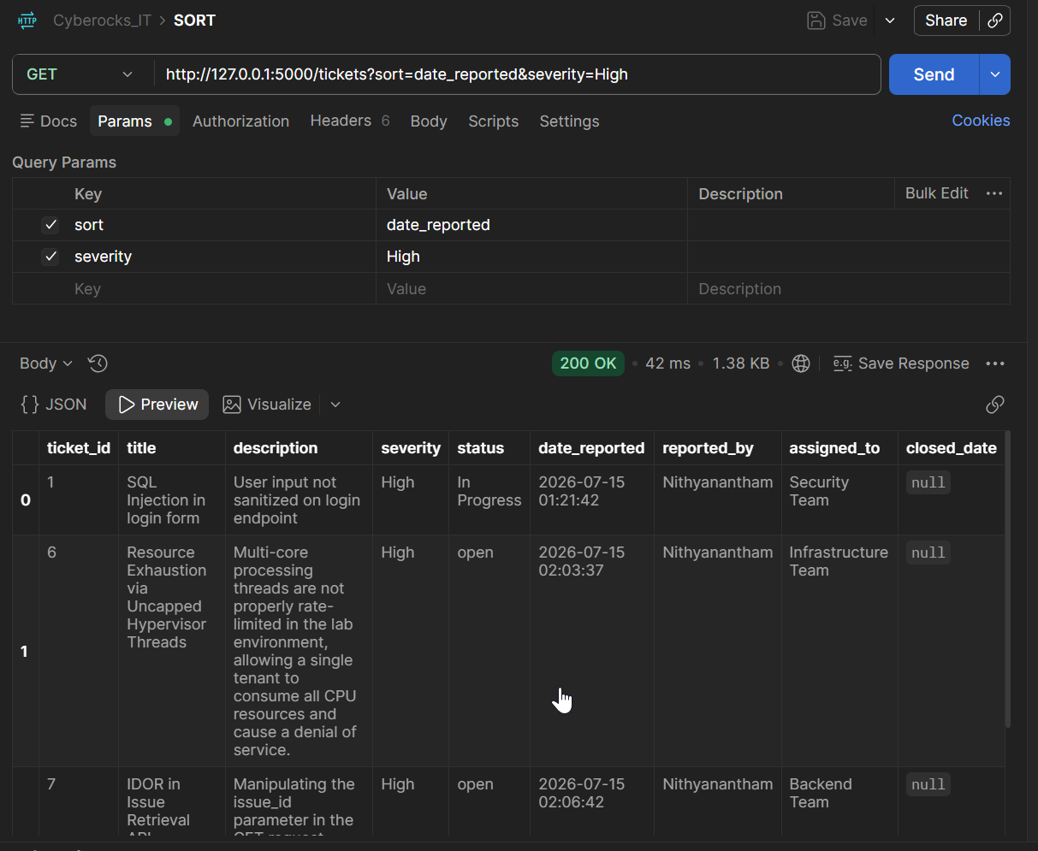
30. SORT by date
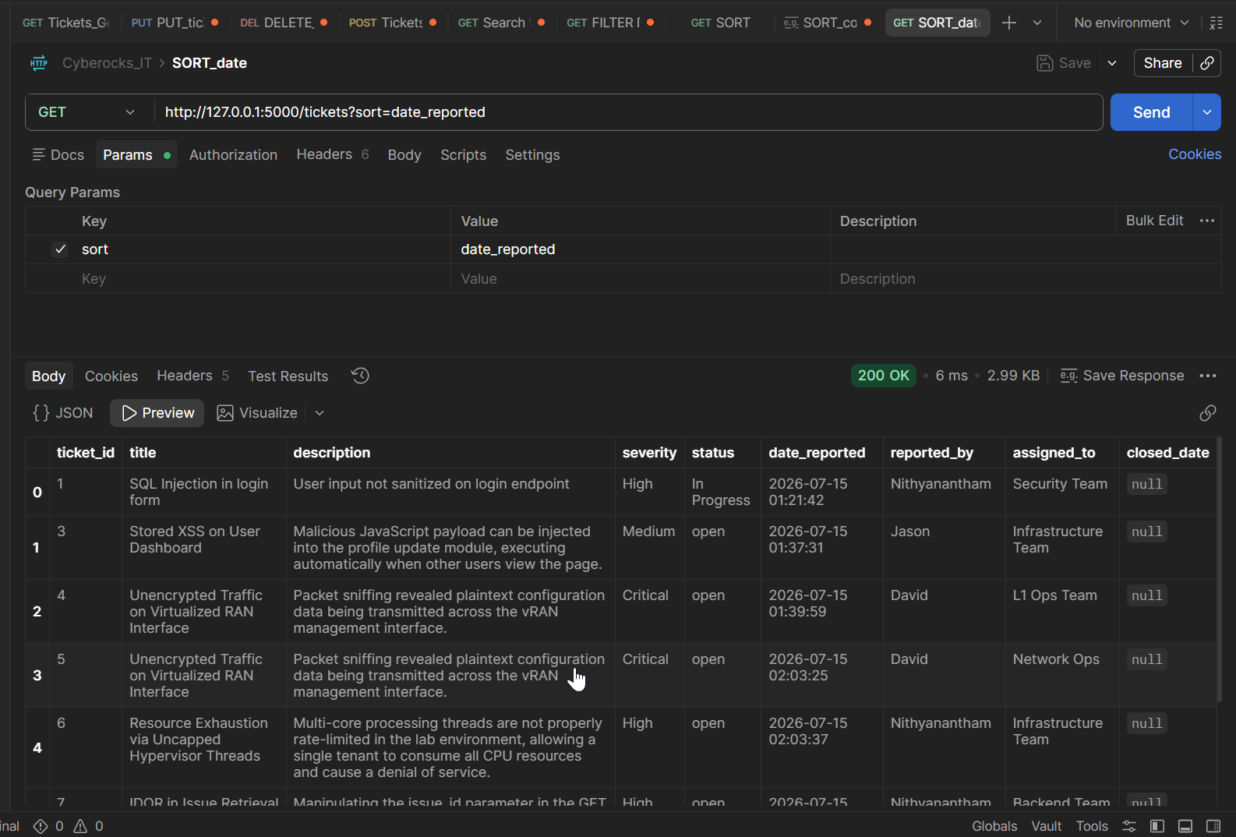
31. REPORT/summary
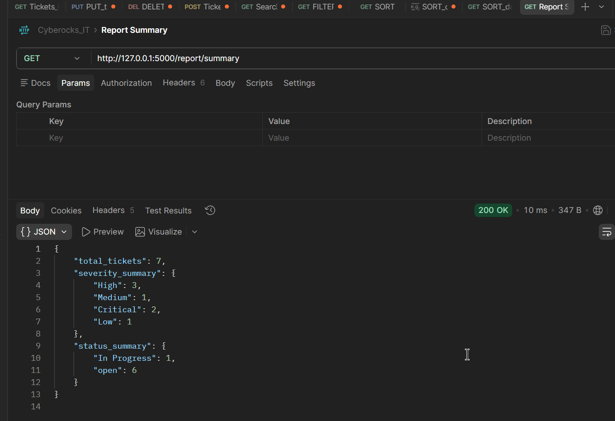
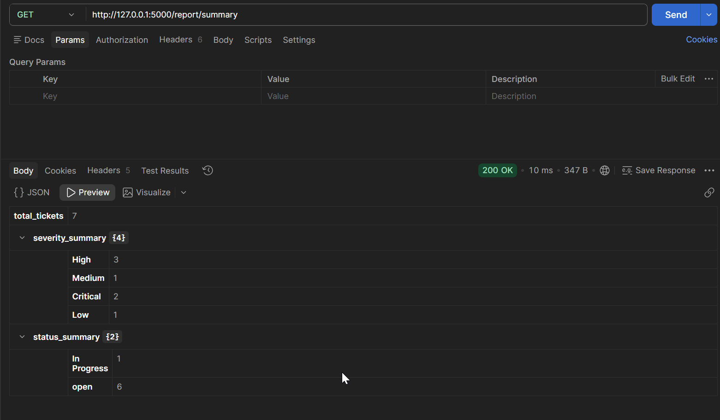

SAMPLE TEST INPUTS:
{
"title": "SQL Injection in login form",
"description": "User input not sanitized on login endpoint",
"severity": "High",
"reported_by": "Nithyanantham",
"assigned_to": "Security Team"
}

{
"title": "Outdated OpenSSL version",
"description": "Server running OpenSSL 1.0.2, end-of-life and unpatched",
"severity": "Medium",
"reported_by": "Nithyanantham",
"assigned_to": "Infrastructure Team"
}

{
"title": "Stored XSS on User Dashboard",
"description": "Malicious JavaScript payload can be injected into the profile update module, executing automatically when other users view the page.",
"severity": "Medium",
"reported_by": "Jason",
"assigned_to": "Frontend Team"
}

{
"title": "Unencrypted Traffic on Virtualized RAN Interface",
"description": "Packet sniffing revealed plaintext configuration data being transmitted across the vRAN management interface.",
"severity": "Critical",
"reported_by": "David",
"assigned_to": "Network Ops"
}

{
"title": "Resource Exhaustion via Uncapped Hypervisor Threads",
"description": "Multi-core processing threads are not properly rate-limited in the lab environment, allowing a single tenant to consume all CPU resources and cause a denial of service.",
"severity": "High",
"reported_by": "Nithyanantham",
"assigned_to": "Infrastructure Team"
}

{
"title": "IDOR in Issue Retrieval API",
"description": "Manipulating the issue_id parameter in the GET request allows an unauthorized user to read vulnerability reports belonging to restricted projects.",
"severity": "High",
"reported_by": "Nithyanantham",
"assigned_to": "Backend Team"
}

{
"title": "Missing HTTP Security Headers",
"description": "The application responses are missing X-Frame-Options and Content-Security-Policy headers, leaving the site vulnerable to clickjacking.",
"severity": "Low",
"reported_by": "Automated Scanner",
"assigned_to": "Security Team"
}

